SISTEMA HOTEL SORRISO
Gabriel Arcanjo Campelo Fadoul¹, Markus Kaul Monteiro Gerrits¹, Miller Raycell Monteiro Correia¹
¹Alunos do Departamento de Ciência da Computação – Universidade Federal de Roraima
gabriel_arcanjo_campelo@hotmail.com, markus_kaul@outlook.com, millerraycell@gmail.com

Abstract. This article refers to the production of the system proposed by the teacher as the final project of the discipline, the system treated is a hotel system, which should be developed in the Java language and use the knowledge acquired in the classes of Object Oriented Programming.
Resumo. Este artigo se refere a produção do sistema proposto pelo professor como projeto final da disciplina, o sistema tratado é um sistema de hotel, que deveria ser desenvolvido na linguagem Java e utilizar os conhecimentos adquiridos nas aulas de Programação Orientada a Objetos.

1. Informações gerais
A proposta do trabalho é que nós alunos da disciplina Programação Orientada a Objetos desenvolvêssemos um sistema de hotel, que se utilizasse dos princípios aprendidos na sala de aula como herança, polimorfismo entre outros. O sistema foi desenvolvido na linguagem Java, que possui predominância de aspectos de orientação a objetos, a IDE utilizada foi o Eclipse Jee.

2. Descrição do Sistema
O sistema é uma aplicação de simples uso, o sistema realiza cadastro de clientes, e cadastro de recepcionistas, o sistema já possui todos os quartos do hotel já cadastrados e um gerente que possui acesso total ao sistema já cadastrado, o gerente pode realizar reservas de quartos e check out também cadastrar recepcionistas. O recepcionista possui um acesso mais limitado ao sistema do que o gerente, dentro do sistema ele pode apenas realizar o check in e check out. O sistema coordena 30 quartos, que são as acomodações que o hotel dispõe.

3. CD-ROMs and Printed Proceedings
In some conferences, the papers are published on CD-ROM while only the abstract is published in the printed Proceedings. In this case, authors are invited to prepare two final versions of the paper. One, complete, to be published on the CD and the other, containing only the first page, with abstract and “resumo” (for papers in Portuguese).

4. Sections and Paragraphs
Section titles must be in boldface, 13pt, flush left. There should be an extra 12 pt of space before each title. Section numbering is optional. The first paragraph of each section should not be indented, while the first lines of subsequent paragraphs should be indented by 1.27 cm.

4.1. Subsections
The subsection titles must be in boldface, 12pt, flush left.

5. Figures and Captions
Figure and table captions should be centered if less than one line (Figure 1), otherwise justified and indented by 0.8cm on both margins, as shown in Figure 2. The caption font must be Helvetica, 10 point, boldface, with 6 points of space before and after each caption.

Figure 1. A typical figure
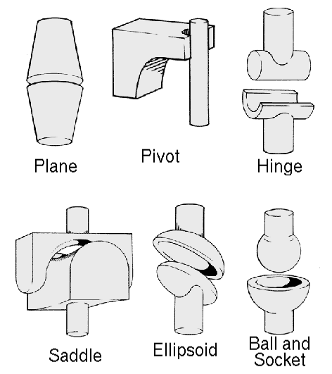
Figure 2. This figure is an example of a figure caption taking more than one line and justified considering margins mentioned in Section 5.
In tables, try to avoid the use of colored or shaded backgrounds, and avoid thick, doubled, or unnecessary framing lines. When reporting empirical data, do not use more decimal digits than warranted by their precision and reproducibility. Table caption must be placed before the table (see Table 1) and the font used must also be Helvetica, 10 point, boldface, with 6 points of space before and after each caption.
Table 1. Variables to be considered on the evaluation of interaction techniques


6. Images
All images and illustrations should be in black-and-white, or gray tones, excepting for the papers that will be electronically available (on CD-ROMs, internet, etc.). The image resolution on paper should be about 600 dpi for black-and-white images, and 150-300 dpi for grayscale images. Do not include images with excessive resolution, as they may take hours to print, without any visible difference in the result.

7. References
Bibliographic references must be unambiguous and uniform. We recommend giving the author names references in brackets, e.g. [Knuth 1984], [Boulic and Renault 1991]; or dates in parentheses, e.g. Knuth (1984), Smith and Jones (1999).
The references must be listed using 12 point font size, with 6 points of space before each reference. The first line of each reference should not be indented, while the subsequent should be indented by 0.5 cm.

References
Boulic, R. and Renault, O. (1991) “3D Hierarchies for Animation”, In: New Trends in Animation and Visualization, Edited by Nadia Magnenat-Thalmann and Daniel Thalmann, John Wiley & Sons ltd., England.
Dyer, S., Martin, J. and Zulauf, J. (1995) “Motion Capture White Paper”, http://reality.sgi.com/employees/jam_sb/mocap/MoCapWP_v2.0.html, December.
Holton, M. and Alexander, S. (1995) “Soft Cellular Modeling: A Technique for the Simulation of Non-rigid Materials”, Computer Graphics: Developments in Virtual Environments, R. A. Earnshaw and J. A. Vince, England, Academic Press Ltd., p. 449-460.
Knuth, D. E. (1984), The TeXbook, Addison Wesley, 15th edition.
Smith, A. and Jones, B. (1999). On the complexity of computing. In Advances in Computer Science, pages 555–566. Publishing Press.

